**WEEK 5– EMPLOYEE DATABASE**

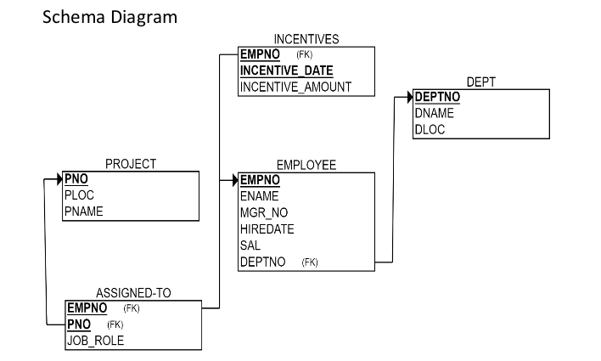

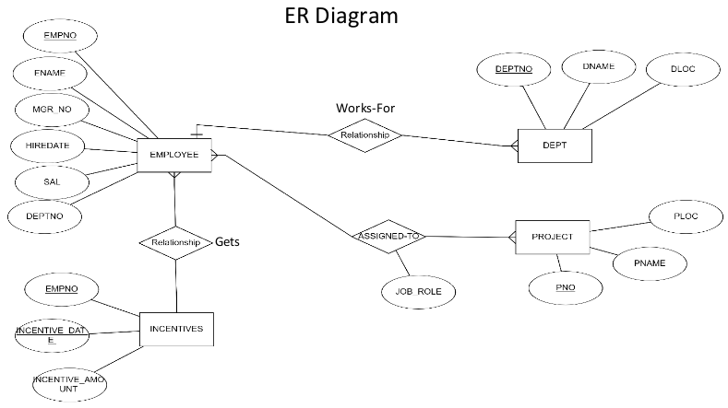

**TO DO:**

1. **Using Scheme diagram, Create tables by properly specifying the primary keys and the foreign keys.**

**(CREATION)**

create database dhiksha_employee;

use dhiksha_employee;

create table dhiksha_employee.project(

pno int,

ploc varchar(40),

pname varchar(40),

PRIMARY KEY(pno)

);

create table dhiksha_employee.dept(

deptno int,

dname varchar(40),

dloc varchar(40),

PRIMARY KEY(deptno)

);

create table dhiksha_employee.employee(

empno int,

ename varchar(40),

mgr_no int,

hiredate date,

sal int,

deptno int,

primary key (empno),

foreign key (deptno) references dept(deptno)

);

create table dhiksha_employee.incentives(

empno int,

incentive_date date,

incentive_amount int,

primary key(incentive_date),

foreign key (empno) references employee(empno)

);

create table dhiksha_employee.assigned_to(

empno int,

pno int,

job_role varchar(50),

foreign key (pno) references project(pno),

foreign key (empno) references employee(empno)

);

1. **Enter greater than five tuples for each table.**

**(INSERTION)**

insert into project values(1,"Bengaluru","Syntax");

insert into project values(2,"Gujurat","Rolex");

insert into project values(3,"Mysuru","Hybrid");

insert into project values(4,"Hyderabad,","Synergy");

insert into project values(5,"Mumbai","Mercury");

insert into dept values(10,"Sales","Bengaluru");

insert into dept values(20,"Finance","West Bengal");

insert into dept values(30,"Marketing","Bihar");

insert into dept values(40,"Purchase","Mumbai");

insert into dept values(50,"Research & Develeopment","Hyderabad");

insert into employee values(100,"Prannay",400,'2003-01-01',100000,10);

insert into employee values(200,"Farhaan",500,'2004-02-02',100500,50);

insert into employee values(300,"Sanika",100,'2003-01-21',200500,30);

insert into employee values(400,"Sakshi", NULL ,'2008-02-17',300500,40);

insert into employee values(500,"Nishith",300,'2004-03-05',200700,40);

insert into employee values(600,"Sohan",200,'2005-11-01',200000,20);

insert into employee values(700,"Mahima",200,'2005-11-21',200900,20);

insert into incentives values(100,'2012-02-17',6000);

insert into incentives values(200,'2012-05-21',7000);

insert into incentives values(400,'2012-07-25',6500);

insert into incentives values(500,'2013-04-19',7400);

insert into incentives values(600,'2013-08-08',8000);

insert into assigned_to values(100,1, "Project Manager");

insert into assigned_to values(200,1, "Resource Manager");

insert into assigned_to values(300,2, "Business Analyst");

insert into assigned_to values(400,3, "Business Analyst");

insert into assigned_to values(500,3, "Project Manager");

insert into assigned_to values(600,5, "Resource Manager");

* **SELECTION**

select * from project;

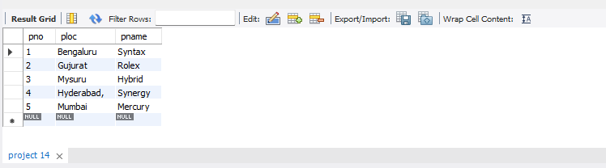

select * from dept;

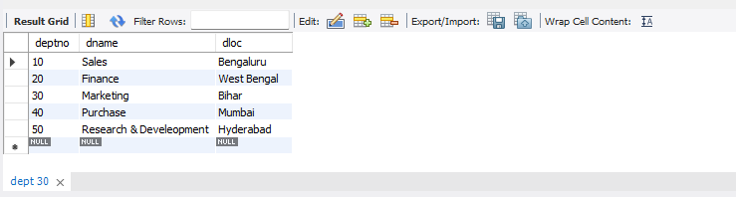

select * from employee;

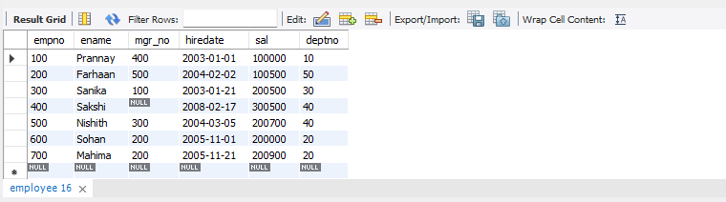

select * from incentives;

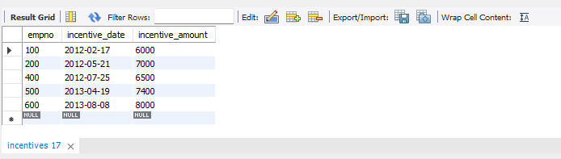

select * from assigned_to;

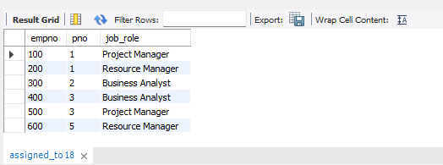

1. **Retrieve the employee numbers of all employees who work on**

**project located in Bengaluru, Hyderabad, or Mysuru.**

select a.empno Employee_number from project p, assigned_to a

where p.pno=a.pno and p.ploc in("Hyderabad","Bengaluru","Mysuru");

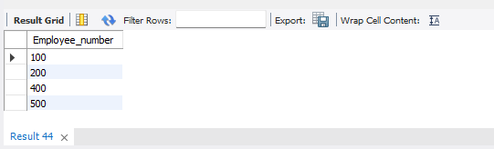

1. **Get Employee ID’s of those employees who didn’t receive incentives**

select e.empno from employee e

where e.empno NOT IN

(select i.empno from incentives i);

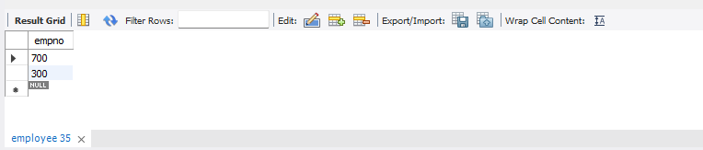

1. **Write a SQL query to find the employees name, number, dept, job_role, department location and project location who are working for a project location same as his/her department location.**

select e.ename Emp_name, e.empno Emp_Number, d.dname Dept, a.job_role Job_Role, d.dloc Department_Location, p.ploc Project_Location

from project p, dept d, employee e, assigned_to a

where e.empno=a.empno and p.pno=a.pno and e.deptno=d.deptno and p.ploc=d.dloc;

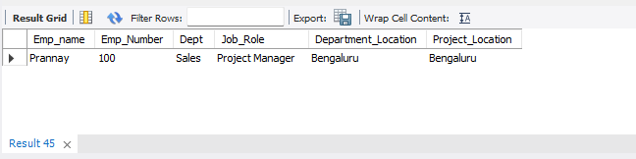

**SPOT QUERY:**

**Find the employee name, dept name and job role of an employee who received maximum incentive in year 2012**

select e.ename, d.dname, a.job_role, MAX(i.incentive_amount) MAX_incentive

from employee e, dept d, incentives i, assigned_to a

where incentive_date between '2012-01-01' and '2012-12-31';

